

Department of Computer Science

University of Gujrat

SILENCE IS HEARABLE



Session: BSCS-20-Morning

Project Advisor: Dr. Zafar Mehmood Khattak

Submitted By
Ayesha Zulfiqar | 20021519-023
Maham Hanif  Noor Ul Ain | 20021519-056  20021519-069

STATEMENT OF SUBMISSION

This is to certify that Ayesha Zulfiqar bearing Roll no. 20021519-023, Maham Hanif bearing Roll No. 20021519-056, and Noor Ul Ain bearing Roll No. 20021519-069 has successfully completed the final year project named as Silence is Hearable at the Department of Computer Science, University of Gujrat, to fulfill the requirement of the degree of Bachelor’s in Computer Science.

______________________ _____________________
Project Supervisor Project Coordination Office
Faculty of C&IT -UOG

______________________
Chairperson
Department of Computer Science

Acknowledgement

We truly acknowledge the cooperation and help make by Dr. Fiaz Majeed, Chairman, Department of Computer Science, University of Gujrat. He has been a constant source of guidance throughout the course of this project. We would also like to thank Dr. Zafar Mehmood Khattak for his help and guidance throughout this project. We are also thankful to our friends and families whose silent support led us to complete our project.

Date:

Abstract

In this Big Universe, there are billions of people who are created by Allah Almighty and The Almighty has blessed all his creation with his blessings. These blessings include the sense of hearing, and speaking but there are some special people out there who do not have these blessings of listening and speaking due to which they can’t communicate like normal people.

Due to their inability to speak or hear they can avail the facility of sign language gestures to communicate. Sign Language is a form of communication that uses hand movements, facial expressions, body postures, and other movements to speak to other people.

There are many existing devices that are designed to help such people to communicate with each other, but these devices are costly and aren’t affordable by everyone. In this project, we are going to design a Sign Language Detection System using American Sign Language (ASL) that will be easily accessible by such people. It is an innovative communication technology designed to facilitate seamless interaction for sign language users.

Table of Contents
Chapter 1: Project Feasibility Report 7
1.1. Introduction 8
1.2. Project/Product Feasibility Report 8
1.2.1. Technical Feasibility 8
1.2.2. Operational Feasibility 8
1.2.3. Economic Feasibility 8
1.2.4. Schedule Feasibility 9
1.2.5. Specification Feasibility 9
1.2.6. Information Feasibility 9
1.2.7. Motivational Feasibility 9
1.2.8. Legal & Ethical Feasibility 9
1.3. Project/Product Scope 9
1.4. Project/Product Costing 9
1.5. Task Dependency Table 9
1.6. CPM - Critical Path Method 10
1.7. Gantt chart 11
1.8. Allocation of Members to Activities 11
1.9. Tools and Technology with reasoning 12
1.10. Vision Document 12
1.11. Product Features/ Product Decomposition 13
Chapter 2: Software Requirement Specification (For Object Oriented Approach) 14
2.1 Introduction: 15
2.2 Systems Specifications 15
2.2.1. Identifying External Entities 15
2.2.2. Context Level Data Flow Diagram: 15
2.2.3. Capture "shall" Statements: 15
2.2.4 Allocate Requirements: 16
2.2.5. Prioritize Requirements (If Any): 18
2.3. Existing Systems / Literature Review: 21
2.3.1. Existing System 21
2.4. Usecase Diagram of Your Project: 22
2.4.1. Usecase Description 24
Chapter 3: Design Document (For Object Oriented Approach) 25
3.1. Introduction: 26
3.2. Domain Model 26
3.3. Design Class Diagram 27
3.4. Sequence Diagram 29
3.5. State chart diagram 30
3.6. Collaboration Diagram 30
a. Contents of Collaboration Diagrams 31
Chapter 4: User Interface Design 32
4.1. Introduction 33
4.2. Site Maps 33
4.3. Story boards 33
4.4. Navigational maps: 35
Chapter 5: Software Testing 36
5.1 Introduction: 37
5.2. Test plan 37
5.2.1. Purpose 37
5.2.2. Outline 37
5.3. Test design specification 41
5.3.1. Purpose 41
5.3.2. Outline 41
5.4. Test Case Specification 44
5.4.1. Purpose 44
5.4.2. Outline 44
5.5. Test procedure specification 46
5.5.1. Purpose 46
5.5.2 Outline 46
5.6. Test item transmittal report 48
5.6.1. Purpose 48
5.6.2. Outline 48
5.7. Test log 49
5.7.1. Purpose 49
5.7.2. Outline 49
5.8. Test incident report 50
5.8.1. Purpose 50
5.8.2. Outline 50
5.9. Test summary report 51
5.9.1. Purpose 51
5.9.2. Outline 51
Chapter 6: Results 53
Chapter 7: User Manual 54
Chapter 8: Conclusion and Future Work 55

Chapter 1: Project Feasibility Report

Introduction

Sign language is a rich and vital form of communication for individuals with hearing impairments. It serves as their primary means of expressing thoughts, ideas, and emotions. However, the gap between sign language and spoken language can sometimes limit effective communication between the hearing-impaired and the hearing community. To bridge this gap, technological advancements in the field of computer vision and machine learning have led to the development of Sign Language Recognition systems. These systems enable the real-time translation of sign language gestures into written or spoken language, facilitating better interaction, and understanding between individuals who use sign language and those who do not.

In this proposal, we outline a project that aims to develop a robust American Sign language detection system using deep learning algorithms. The proposed system comprises of the key module: Sign language detection using computer vision (Deep learning algorithms) with facial expression analysis.

The sign language detection system will be deployed in a Mobile App. The smartphone’s mobile app will use the embedded camera to detect and understand the user’s input of sign language expressions & will convert it into American English text which will be easily understandable by the listener.

The system will facilitate the deaf and mute people to communicate effectively and somehow overcome the disability of hearing and speaking. The system will primarily focus on detecting sign language gestures while detecting facial expressions to enhance accuracy and context understanding. The goal is to create a real-time application that can recognize sign language gestures and interpret their corresponding meanings.

1.2. Project/Product Feasibility Report
When a project is started the first matter to establish is to assess the feasibility of a project or product.
There are many types of feasibilities:

- Technical
- Operational
- Economic
- Schedule
- Specification
- Information
- Motivational
- Legal and Ethical

1.2.1. Technical Feasibility
Our Project’s technical feasibility is possible but to train our AI Model we need large dataset and that is not available. So, one of the main processes includes data gathering. Our app utilizes a combination of Python programming language, Mediapipe (open source library), Harcascade classifier and TensorFlow , a popular open-source machine language framework. The integration of Python, TensorFlow, CNNs (Convolutional Neural Networks), and LSTM empower the model to accurately interpret sign language and convert them into text, along with facial expression analysis. We are using Flutter framework to create Fast and Scalable Mobile Application. American Sign Language is our Primary language for Dataset Collection.

1.2.2. Operational Feasibility
The app is designed with user-friendliness in mind, offering intuitive interface for individuals with hearing and speaking disability. It uses AI models (CNN, LSTM) that detects signs being shown through a live camera of mobile device to generate quick response.

1.2.3. Economic Feasibility
The economic feasibility of our app has been enhanced through strategic investments, including the acquisition of Google Colab resources.

Investment in Google Colab: Since our project required higher GPU for faster training, we have Purchased Google Colab Pro Subscription to ensure faster model training. By leveraging Colab’s computational power for training and development processes, the project has efficiently managed resource-intensive tasks while optimizing budget allocation.

1.2.4. Schedule Feasibility
The schedule feasibility of the AI-based sign language recognition and conversion app is essential in evaluating the project’s ability to be completed within the allocated time frame.

Project Milestones: The project’s timeline is structured around key milestones, including dataset collection, data preprocessing, model development, testing, integrating the model & deployment. Each milestone is carefully planned to ensure efficient progress and alignment with project objectives.
Development Phases: The development process is divided into phases, allowing for focused work on specific aspects of the app. This structured approach streamlines development, ensures efficient resource allocation, and minimizes the risk of delays.

Agile Development: The project follows an agile development methodology, allowing for flexibility and adaptability to changing circumstances. Regular review and adjustment of milestones enable the team to respond to feedback, improvements, and emerging requirements in real-time.

1.2.5. Specification Feasibility
The specification feasibility of our project evaluates the alignment of its features and functionalities with the project’s objectives and user requirements.
- The apps core feature of interpreting sign language gestures and converting them into accurate text aligns precisely with the project’s primary objective.
- The incorporation of CNN, LSTM models and efficient preprocessing enables real-time conversion of sign language gestures to text. This specification enhances app’s practicality for dynamic communication.

1.2.6. Information Feasibility
Assessing the feasibility of information for your Sign Language Recognition Mobile App includes evaluating the completeness, reliability, and meaningfulness of the data and information used and generated by the system. This involves collecting comprehensive datasets, ensuring high model accuracy, maintaining system stability, and providing meaningful output to users.
- Completeness:
Training Data: The CNN models require a comprehensive dataset of sign language gestures and facial expressions for accurate recognition. It is ensured that the dataset covers a wide range of signs and expressions.

User Input Data: The app must capture complete and high-quality video input from the mobile camera. Implementing real-time video capture with sufficient resolution and frame rate to ensure that CNN model can interpret the signs accurately.
- Reliability:
Model Accuracy: The AI models must reliably recognize signs and expressions from the video input with high accuracy. Regularly evaluate the models using validation datasets to ensure consistent performance. Implement fallback mechanisms for ambiguous or unrecognized inputs.
System Stability: The app must perform reliably without frequent crashes or errors. Conduct extensive testing to identify and fix potential issues. Implement robust error handling and logging.
- Meaningfulness:
User Feedback: The textual output generated by the app must be meaningful and useful to the users. Ensure that the output is contextually accurate and easy to understand. Provide options for users to give feedback on the accuracy and relevance of the output.
User Interface: The interface must present information in a clear and meaningful way to the users. Design a user-friendly interface that prioritizes usability and accessibility. Use clear and concise text for output display. Incorporate user interface best practices to enhance readability and interaction.

1.2.7. Motivational Feasibility
The Motivational feasibility of app centers on driving forces and passionate commitment
behind the project, along with its potential positive impact on individuals and society.
- The project is deeply rooted in a strong personal motivation to make a meaningful
difference in the lives of individuals with hearing impairments.
- The app’s ability to empower individuals to effectively communicate and access
information irrespective of their hearing impairments is a motivating factor.
- The motivation behind the project extends beyond its initial launch. We are
motivated to continuously innovate, refine and expand the app’s capabilities
ensures that the project remains relevant and impactful over time.

1.2.8. Legal & Ethical Feasibility
The legal and ethical feasibility of the app addresses the crucial considerations surrounding data privacy, fairness, accessibility and compliance with relevant laws and ethical standards.

Data Privacy: The app prioritizes user data privacy so we have an authentication system so users can keep their data secret and we only collect information relevant to our product.
Fairness and Bias Mitigation: Rigorous measures have been implemented to ensure the app’s AI model are free from biases and capable of providing accurate interpretations across diverse sign language variations.
Accessibility: The app’s development aligns with accessibility standards, ensuring that individuals with disabilities have equal access to its functionalities.

1.3. Project/Product Scope
The scope of the Silence is Hearable Mobile App project is a critical factor in determining its success. It involves defining the boundaries of the system, detailing what is included within the project, and what is outside its context.
Scope & Context:
Context: The context of the project includes the external environment and factors that impact the system but are not within its control. This includes:
- The community of users who will benefit from the app, such as the deaf and hard-of-hearing individuals and their communication partners.
- The broader technological landscape, including advancements in AI, machine learning, and mobile app development.
- Potential future integrations, such as adding support for additional languages or expanding the app to include voice output.

Scope: The scope defines the specific requirements and functionalities that are included within the system. This includes:
- Real-Time Video Capture: The app will capture video input from the mobile camera in real-time.
- AI Model Integration: Implementing AI models that recognize sign language gestures and facial expressions from the video input.
- Textual Output Display: Displaying the interpreted sign language as text on the user interface.
- User Interface: Developing a user-friendly interface that allows easy interaction with the app.
- Error Handling: Ensuring robust error handling to manage any issues during real-time processing.
- Performance Optimization: Ensuring the app operates with minimal latency to provide a smooth user experience.

Managing Project Scope: Managing the scope of the project to fit the available resources (time, people, and money) is essential for its success. This involves continuous activities such as iterative or incremental development, breaking the project scope into smaller, more manageable pieces. The scope management process includes:

- Requirement Attributes: Using attributes such as priority, effort, and risk to negotiate the inclusion of requirements.
- Priority: Identifying the most critical features that must be implemented first. For example, real-time video capture and AI model integration are high-priority features.
- Effort: Estimating the effort required to implement each feature. Features like performance optimization may require significant effort and need careful planning.
- Risk: Assessing the risks associated with each requirement. For instance, integrating AI models may carry technical risks that need to be mitigated through extensive testing.
- Iterative Development: Breaking down the project into smaller iterations allows for gradual development and testing of features.
- First Iteration: Implementing basic video capture and AI model integration.
- Subsequent Iteration: Adding user interface enhancements, performance optimizations, and additional error handling features.
- Scope Negotiation: Focusing on requirement attributes helps desensitize negotiations and make objective decisions about what to include in each iteration.
- Negotiation Based on Priority: High-priority features are included in early iterations, while lower-priority features may be scheduled for later.
- Effort and Resource Allocation: Balancing the effort required with the available resources to ensure that the project remains on schedule and within budget.
- Risk Management: Addressing high-risk requirements early in the development process to mitigate potential issues.

1.4. Project/Product Costing
The project costing reflects reduced expenses due to the acquisition of Colab resources and hosting services.
- Google Colab: 29.84$ USD

1.5. Task Dependency Table
Task No. | Task Description | Task Dependency
T1 | Define project scope and objectives | -
T2 | Research existing sign language recognition systems | T1
T3 | Select appropriate deep learning algorithms and tools | T1
T4 | Collect and preprocess sign language data | T2, T3
T5 | Train sign language recognition models | T4
T6 | Integrate facial expression analysis | T5
T7 | Develop the mobile app interface | T5
T8 | Implement sign language detection module in the app | T7
T9 | Integrate the trained model into app | T5, T8
T10 | Test the app for performance | T9
T11 | Optimize the model and app based on predictions | T10
T12 | Conduct user testing | T10
T13 | Make necessary adjustments and improvements | T11
T14 | Monitor app performance | -

1.6. CPM - Critical Path Method
Activity | Description | Immediate Predecessor | Duration (Weeks)
A | Define project scope and objectives | None | 2
B | Research existing systems | A | 3
C | Select algorithms and tools | A | 2
D | Collect and preprocess data | B, C | 4
E | Train recognition model | D | 5
F | Integrate facial expression analysis | E | 3
G | Develop mobile app interface | E | 4
H | Implement detection module | G | 3
I | Integrate the trained model | F, H | 2
J | Test for accuracy and performance | I | 2
K | Optimize based on predictions | J | 2
L | Conduct user testing | K | 2
M | Adjustments and improvements | L | 2
N | Monitor performance | M | 2

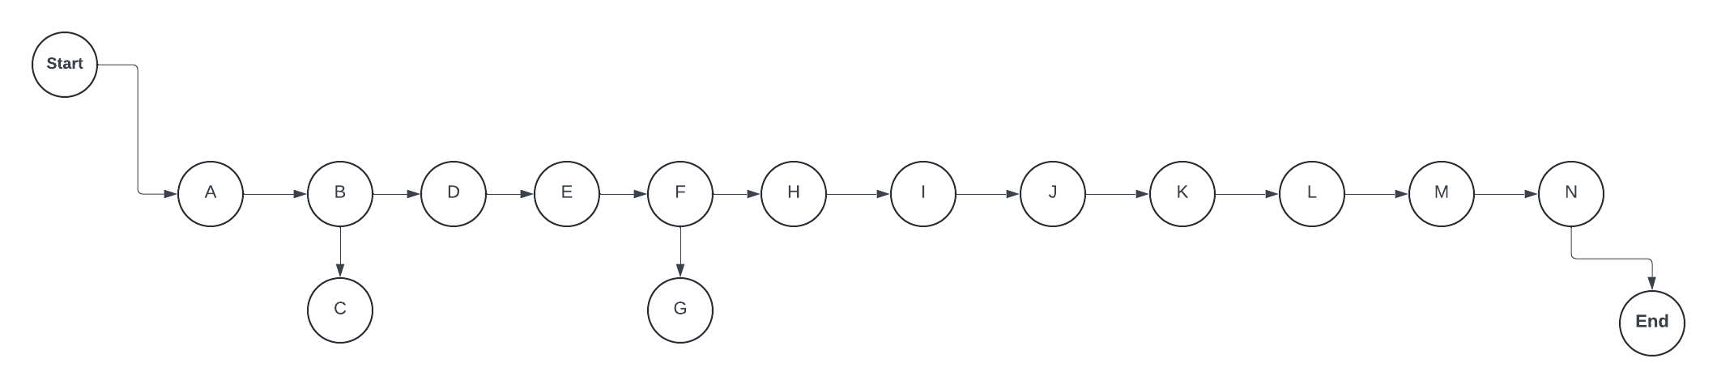
Figure 1.6 CPM Diagram

1.7. Gantt chart
Sr. No. | Tasks | Start Date | End Date | Jul | Aug | Sep | Oct | Nov | Dec | Jan | Feb | Mar | Apr
1 | Define project scope & objectives | 24-07-23 | 6-08-23
2 | Research existing systems | 7-08-23 | 27-08-23
3 | Select algorithms and tools | 28-08-23 | 10-09-23
4 | Collect and preprocess data | 11-08-23 | 8-10-23
5 | Train recognition model | 9-10-23 | 12-11-23
6 | Integrate facial expression analysis | 13-11-23 | 3-12-23
7 | Develop mobile app interface | 4-12-23 | 31-12-23
8 | Implement detection module | 1-01-24 | 21-01-24
9 | Integrate the trained model | 22-01-24 | 4-02-24
10 | Test for accuracy and performance | 5-02-24 | 18-02-24
11 | Optimize based on predictions | 19-02-24 | 3-03-24
12 | Conduct user testing | 4-03-24 | 17-03-24
13 | Adjustments and improvements | 18-03-24 | 31-03-24
14 | Monitor performance | 1-04-24 | 15-04-24

1.8. Allocation of Members to Activities
1.8.1. Introduction to Team Members and their Skill Set

Member Name | Skill Set
Ayesha Zulfiqar | Python Development, Model Training
Maham Hanif | Python Development, Model Training
Noor Ul Ain | Mobile App Development

1.8.2 Task and Member Assignment Table

Member Name | Task
Ayesha Zulfiqar | T1, T2, T3, T4, T5, T6, T8, T10, T11, T12, T13, T14
Maham Hanif | T1, T2, T3, T4, T5, T8, T10, T11, T12, T13, T14
Noor Ul Ain | T1, T2, T7, T9, T10, T12, T13, T14
1.8.3 Task Durations and Dependencies

Task | Duration (Days) | Dependencies
T1 | 14 | - (M1, M2, M3)
T2 | 21 | T1 (M1, M2, M3)
T3 | 14 | T1 (M1, M2)
T4 | 28 | T2, T3 (M1, M2)
T5 | 35 | T4 (M1, M2)
T6 | 21 | T5 (M1)
T7 | 28 | T5 (M3)
T8 | 21 | T7 (M1, M2)
T9 | 14 | T5, T8 (M3)
T10 | 14 | T9 (M1, M2, M3)
T11 | 14 | T10 (M1, M2)
T12 | 14 | T10 (M1, M2, M3)
T13 | 14 | T11 (M1, M2, M3)
T14 | 14 | - (M1, M2, M3)

1.9. Tools and Technology with reasoning
- Google Colab (Jupyter Notebook’s Hosting Service Provider): Will be used as IDE to train models.
- Android Studio: Will be used as IDE for developing Android Mobile Application.
- Dart & Python: Programming Languages.
- Flutter: For making cross-platform mobile applications that will act as an interface.
- TensorFlow & TensorFlow Lite: A tool that will be used to train our model, using deep learning and CNN.
- OpenCV: Used for image & video preprocessing.
- Keras: A high-level neural network library that runs on top of TensorFlow to train models.
- Convolutional Neural Network – CNN: The tool is used for the extraction of features from images.
- LSTM: (Long Short-Term Memory) is designed for capturing long-term dependencies and patterns in sequential data, enhancing prediction accuracy.
- Firebase: Google’s database for user registration, and authentication.
- Flask: Utilizing flask to deploy and integrate our AI models into our mobile application.

1.10. Vision Document
The purpose of this vision document is to outline the goals, scope, and high-level requirements for the development of a Sign Language Recognition Mobile App. This document serves as a guide for stakeholders and provides the basis for detailed technical requirements and project planning.

This project aims to develop a mobile application that utilizes computer vision and deep learning algorithms to detect and interpret American Sign Language (ASL) gestures and facial expressions in real-time, converting them into American English text. This will facilitate better communication between individuals who use sign language and those who do not.

Sign language is an essential form of communication for individuals with hearing impairments. However, the gap between sign language and spoken language can hinder effective communication. The proposed system aims to bridge this gap by leveraging technological advancements in computer vision and machine learning.

1.10.1 Stake Holders

• Primary Users: Deaf and mute individuals who rely on sign language for communication.
• Secondary Users: Family members, friends, educators, and the general public who interact with sign language users.
• Developers: The team responsible for developing and maintaining the mobile application.
• Project Sponsors: Organizations or individuals funding the project.
• Regulatory Bodies: Authorities ensuring compliance with accessibility and technology standards.

1.11. Product Features/ Product Decomposition
The functional requirements of our project are divided into key features and corresponding tasks or functions the system is required to perform.

1.11.1. Real-Time ASL Gesture Recognition
Feature: The system must recognize and interpret American Sign Language (ASL) gestures in real-time.
- Task 1: Capture real-time video from the mobile device's camera.
Description: The application must access the device’s camera to continuously capture video frames.
Requirement: The application should request and manage necessary camera permissions.
- Task 2: Process video frames to detect facial expressions and ASL gestures.
Description: The system must analyze the captured video frames using computer vision algorithms to detect hand movements corresponding to ASL gestures.
Requirement: The processing should be optimized for real-time performance.
- Task 3: Translate detected ASL gestures into text.
Description: The application should convert the recognized ASL gestures into corresponding English text.
Requirement: The translation should be accurate and contextually relevant.

1.11.2. Facial Expression Analysis
Feature: Enhance communication accuracy by analyzing facial expressions.
- Task 1: Detect facial expressions in video frames.
Description: The system must analyze the user's facial expressions to provide additional context to the communication.
Requirement: Use facial recognition algorithms to identify expressions such as happy, sad, angry, surprise, and neutral.

1.11.3. User Interface (UI) Design
Feature: Provide a user-friendly and accessible interface. Display recognized text in real-time.
- Description: Show the translated text on the screen as gestures are recognized.
- Requirement: The text display should update dynamically and be clearly visible.

Chapter 2: Software Requirement Specification (For Object Oriented Approach)

2.1 Introduction:
The Sign Language Detection app is designed to bridge communication barriers for individuals with hearing impairments. Through a systematic gathering of user needs, functional specifications and technical considerations, we have crafted a solution that seamlessly translates sign language gestures into text, bringing interactions between hearing and non-hearing communities. By having a keen eye on the Requirements Engineering process, we ensure that our app not only meets user expectations but also exceeds them.

2.2 Systems Specifications
The following are the clauses that are included in our system specifications.

2.2.1. Identifying External Entities
The Identification of External Entities is done in two phases.

a. Over Specify Entities from Abstract
Based on abstract one might identify the following entities:
- System Core Entities (Sign Language Detection System, Gesture Recognition Module, Facial expression Analysis Module, Translation Module, User-Interface Module)
- Input Entities (Camera, User)
- Output Entities (Display)
- Device Entities (Mobile Device, Computer)
b. Perform Refinement
After over specifying the entities, you have to refine them on the basis of your business logic. For example, in this example we found the following entities more related to our business logic:
- User
- Mobile
- Camera
- Sign Language Detection Model

2.2.2. Context Level Data Flow Diagram:
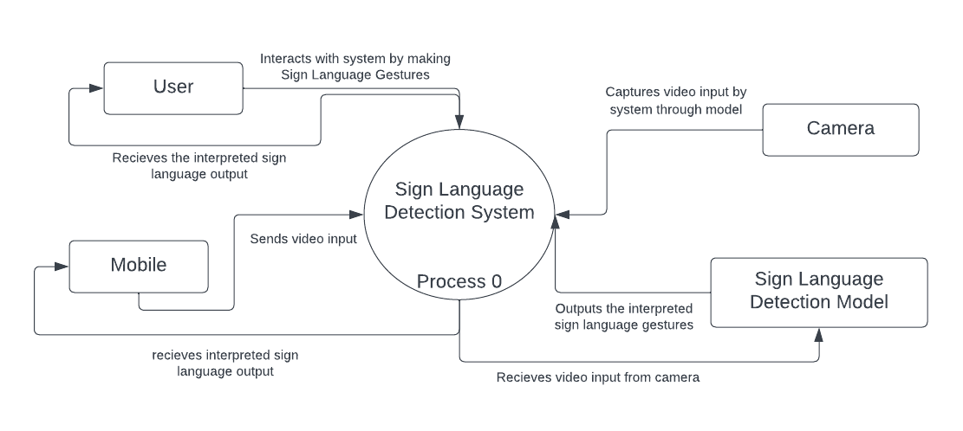

2.2.3. Capture "shall" Statements:
Para# | Initial Requirements
1 | The user shall be able to register into the mobile app
1 | The user shall be able to login
1 | The user shall be able to access mobile device’ camera for recording sign language gestures
1 | The user shall be able to record the input sign language gesture and send it to the deep learning algorithms
1 | The deep learning algorithm shall be able to process the video input
1 | The deep learning algorithm shall generate textual output
1 | The user shall be able to provide the feedback for detection response
1 | The user shall be able to logout of the application

2.2.4 Allocate Requirements:
Para# | Initial Requirements | Usecase Name
1 | The user “shall” be able to register into the mobile app | UC_Registration
1 | The user “shall” be able to login | UC_Login
1 | The user “shall” access mobile device’ camera | UC_Camera_Access
1 | The user “will” record input into camera | UC_Input
1 | The deep learning algorithm “will” process the input video | UC_Detection
1 | The deep learning algorithm “will” generate textual output | UC_Generate_Output
1 | The user “shall” be able to give feedback on detection | UC_Feedabck
1 | The user “shall” be able to logout of the account | UC_Logout

2.2.5. Prioritize Requirements:
Para# | Rank | Initial Requirements | Usecase ID | Usecase Name
1 | Highest | The user “shall” be able to register into the mobile app | UC_1 | UC_Registration
1 | Highest | The user “shall” be able to login | UC_2 | UC_Login
1 | Highest | The user “shall” access mobile device’ camera | UC_3 | UC_Camera_Access
1 | Highest | The user “will” record input into camera | UC_4 | UC_Input
1 | Highest | The deep learning algorithm “will” process the input video | UC_5 | UC_Detection
1 | Highest | The deep learning algorithm “will” generate textual output | UC_6 | UC_Generate_Output
1 | Medium | The user “shall” be able to give feedback on detection | UC_7 | UC_Feedabck
1 | Lowest | The user “shall” be able to logout of the account | UC_8 | UC_Logout

2.3. Existing Systems / Literature Review:
Existing System
There exists a system of Sign Language Detection which takes the input in the form of images and generated an output in the form of 1 or 2 words. In the existing system, the facial expression analysis module was not included in the system but the system we are going to propose generates the output in the form of ASL (American Sign Language Sentence) sentence based on 2 or 3 words and also includes the facial expression analysis module to make communication more comprehensive and exclusive for the non-hearing community.

2.4. Usecase Diagram of Your Project:
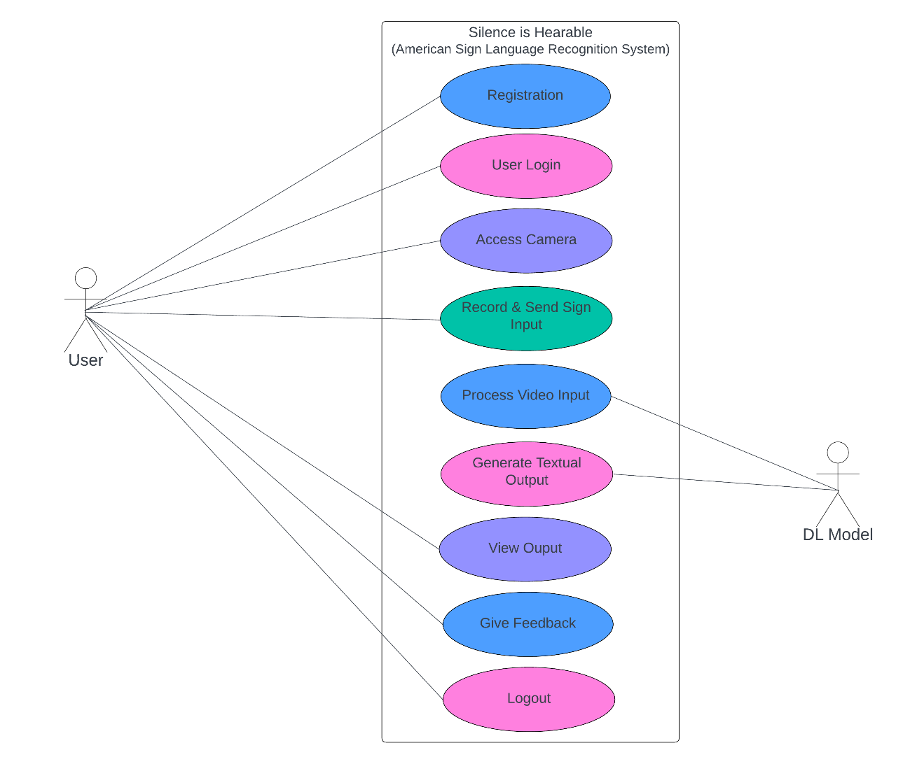

2.4.1. Usecase Description

UC_Registration (UC_1)

Use Case Description
Use Case ID | UC_1
Use Case Name | UC_Registration
Description | Allows a user to register for an account in the app and access the functionalities of the app
Preconditions | None
Basic Flow | - User selects the registration option  - User provides required registration details  - App validates the provided information  - App stores the registration details for the user
Alternate Flows | If the provided registration information is incomplete or invalid:  - App prompts the user to provide accurate details  - Process continues from step (b) of basic flow
Post Conditions | The user’s registration details are stored in the system

UC_Login (UC_2)
Use Case Description
Use Case ID | UC_2
Use Case Name | UC_Login
Description | Allows a user to login into the created account on the application
Preconditions | The user has registered account before logging in.
Basic Flow | - The user opens the app and taps on login option  - User enters their username and password  - App validates the entered credentials against the stored user data  - If the credentials are valid, the app grants access to the user  - App displays the main interface with access to the user
Alternate Flows | If the entered credentials are invalid:  - App notifies the user that the credentials are incorrect  - User is prompted to re-enter the email & password  - Process continues from step (c) of the basic flow
Post Conditions | The user gains the access to the app’s interface

UC_Camera_Access (UC_3)

Use Case Description
Use Case ID | UC_3
Use Case Name | UC_Camera_Access
Description | Enables the user to access the mobile device's camera for recording sign language gestures.
Preconditions | The user has selected the option to access the mobile camera for recording the sign language as input to the system
Basic Flow | - User select the option to access the mobile camera for gesture input  - App requests access to the user’s mobile camera.  - User grants camera access permission.  - App activates the mobile camera to capture real-time video input.  - App processes captured video frames through the DL models for gesture interpretations and facial expression analysis  - App displays the real-time interpretation of the detected sign language gestures.
Alternate Flows | If the user denies camera access permission:  - App notifies the user that camera access is required for gesture input.  - Process terminates.
Post Conditions | App displays the real-time interpretation of the detected sign language gestures as an output.

UC_Input (UC_4)

Use Case Description
Use Case ID | UC_4
Use Case Name | UC_Input
Description | Captures video input recorded by the user and sends it to the deep learning algorithm for processing.
Preconditions | The user has gained the access to camera for recording the video input
Basic Flow | - The user positions the camera to focus on their signing gestures.  - The user initiates the video capture process by clicking a "Record" button.  - The app records the video input in real-time.  - During the recording, the user performs the desired sign language gestures.  - Once the user completes the signing session, they click a "Stop" button to end the recording.  - The app processes the recorded video and prepares it for sending.  - The user clicks a "Send" button to transmit the video input to the deep learning algorithm for analysis.
Alternate Flows | - If the user decides to cancel the video capture before clicking "Stop," they can click a "Cancel" button.  - The app discards the recording in progress, and the user returns to the previous screen without submitting any video input.  - No data is sent to the deep learning algorithm in this scenario.  - If the app does not have the necessary permissions to access the camera, the system prompts the user to grant permission.  - If the user denies permission, the app provides an error message, and the video capture process is halted.
Post Conditions | - The recorded video is successfully sent to the deep learning algorithm for processing.  - The app provides visual feedback to the user, indicating that the video input has been captured and sent.

UC_Detection (UC_5)

Use Case Description
Use Case ID | UC_5
Use Case Name | UC_Detection
Description | Processes the video input, detects facial expressions and sign gestures made by the user.
Preconditions | The user has initiated the process to capture and has sent the video input.
Basic Flow | - The recorded video is sent to the deep learning algorithm for processing.  - The deep learning algorithm analyzes the video input to detect facial expressions and sign gestures.
Alternate Flows | - If the deep learning algorithm does not detect any sign gesture in the video, the system provides feedback to the user.  - The user is informed that no recognizable sign gesture was detected.  - The system may prompt the user to re-record the video or provide additional instructions for better recognition.
Post Conditions | The system displays the generated textual output to the user.

UC_Output (UC_6)

Use Case Description
Use Case ID | UC_6
Use Case Name | UC_Output
Description | Generates text-based output corresponding to the input sign gestures.
Preconditions | The deep learning algorithm must be available and operational.
Basic Flow | - The system retrieves the recorded video input from the user.  - The deep learning algorithm processes the video input to detect facial expressions and sign gestures.  - Based on the analysis, the algorithm generates a textual output corresponding to the recognized sign language.  - The system presents the generated text output to the user on the app interface.
Alternate Flows | - In case the algorithm encounters difficulty in recognizing the sign language gesture, it may prompt the user to re-record the gesture.  - The user has the option to re-record the gesture, providing another opportunity for the algorithm to generate accurate text output.
Post Conditions | The system prompts the user to give feedback on the detection

UC_Feedback (UC_7)

Use Case Description
Use Case ID | UC_7
Use Case Name | UC_Feedback
Description | This use case enables users to provide feedback on the accuracy and quality of the sign language gestures interpretation provided by the app.
Preconditions | The user must have completed a session of using the app's sign language recognition features.
Basic Flow | - User receives the interpreted textual content from the app's detection response.  - User selects the option to provide feedback on the interpretation.  - App activates the user to share their feedback through a designed interface.  - User enters their feedback regarding the accuracy or any discrepancies within the interpretation.  - App records the user's feedback along with the corresponding detection response.
Alternate Flows | If the user chooses not to provide feedback:  - User dismisses the feedback prompt.  - Process terminates.
Post Conditions | The system acknowledges the successful submission of feedback to the user.

UC_Logout (UC_8)

Use Case Description
Use Case ID | UC_8
Use Case Name | UC_Logout
Description | The user shall be able to logout of the application.
Preconditions | The user must be currently logged into the mobile app.
Basic Flow | - The user, while actively using the mobile app, decides to log out.  - The user navigates to the app's settings or profile section where the "Logout" option is available.  - The user taps on the "Logout" button.  - The system confirms the user's intention to log out, displaying a confirmation dialog or message.  - Th e user confirms the logout action.  - The app returns to the login screen or an initial screen, indicating that the user has successfully logged out.
Alternate Flows | - If, during the confirmation step (step d) of basic flow, the user decides not to log out, they can cancel the operation.  - The system returns to the previous screen, and the user remains logged in.
Post Conditions | The user is redirected to an appropriate screen (e.g., login screen or home screen).

Chapter 3: Design Document (For Object Oriented Approach)

Introduction:
In this module, we will discuss the functional solution to our problem. In the previous
module, analysis of the system is completed. So, we understand the current situation of
the problem domain. Now we are ready to strive for a solution for the problem domain by
using object-oriented approach.

- Domain Model
- Design Class Diagram
- Sequence Diagram
- State Chart Diagram
- Collaboration Diagram

Domain Model
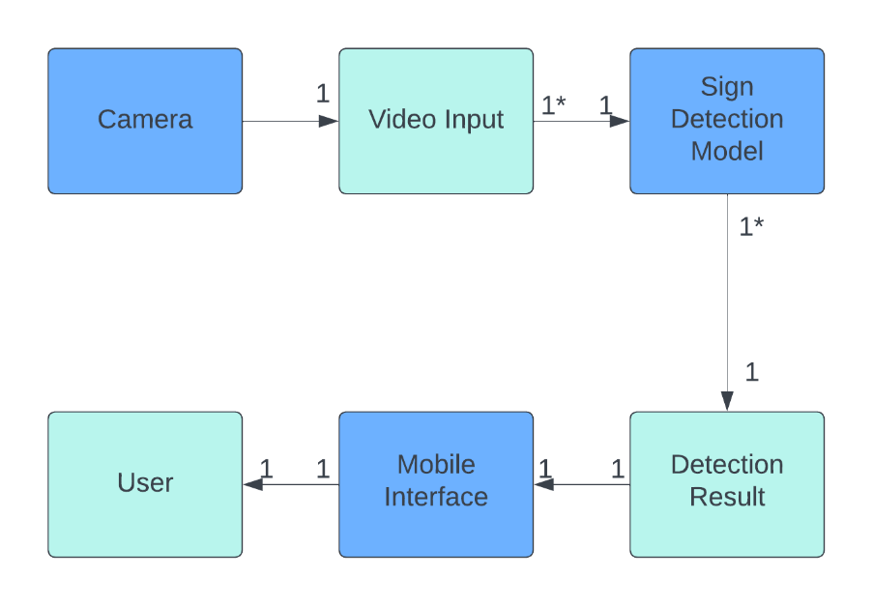
Figure 3.2 Domain Model

Design Class Diagram
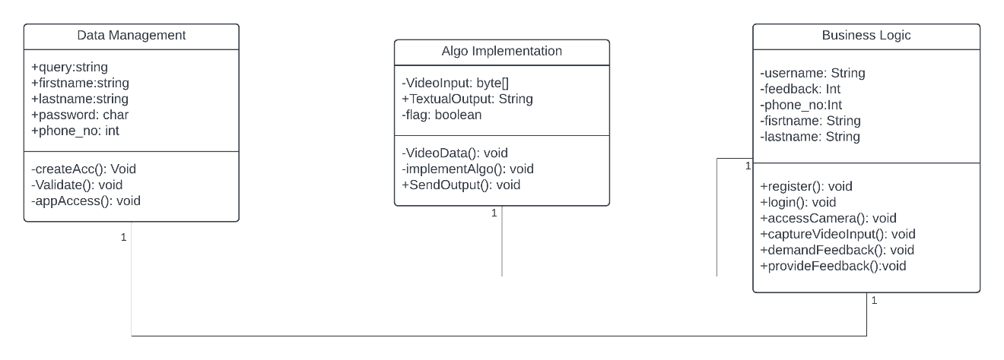
Figure 3.3 UML Class Diagram

Sequence Diagram

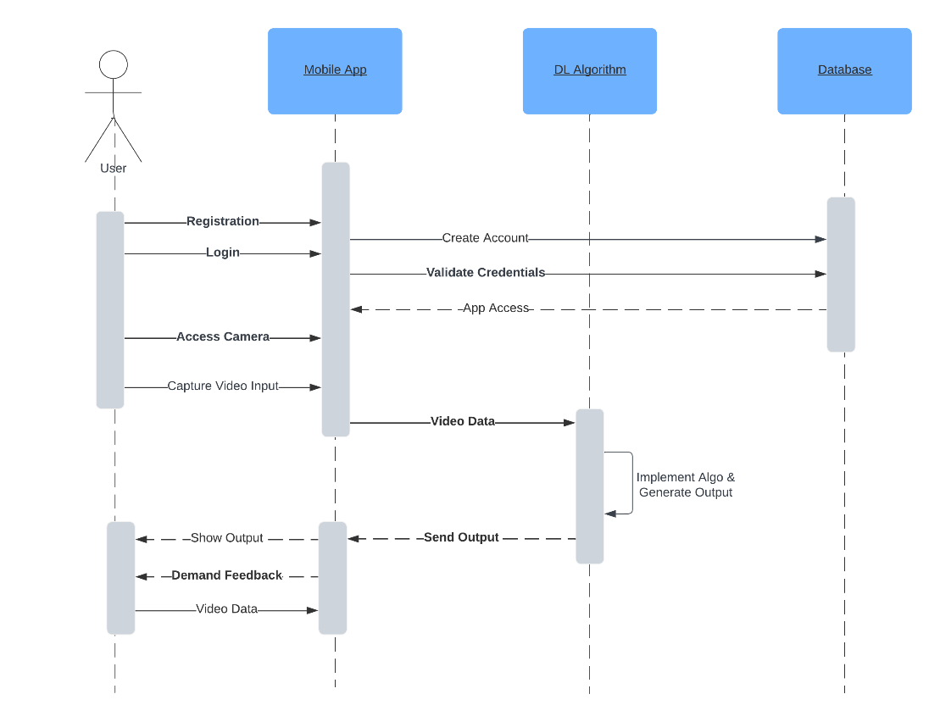
Fig 3.4 Sequence Diagram

Distributing Control Flow in Sequence Diagrams

Since our app has only one primary module, the Sequence diagram in Fig 3.4 is enough to show the distribution of Flow of app.

State chart diagram
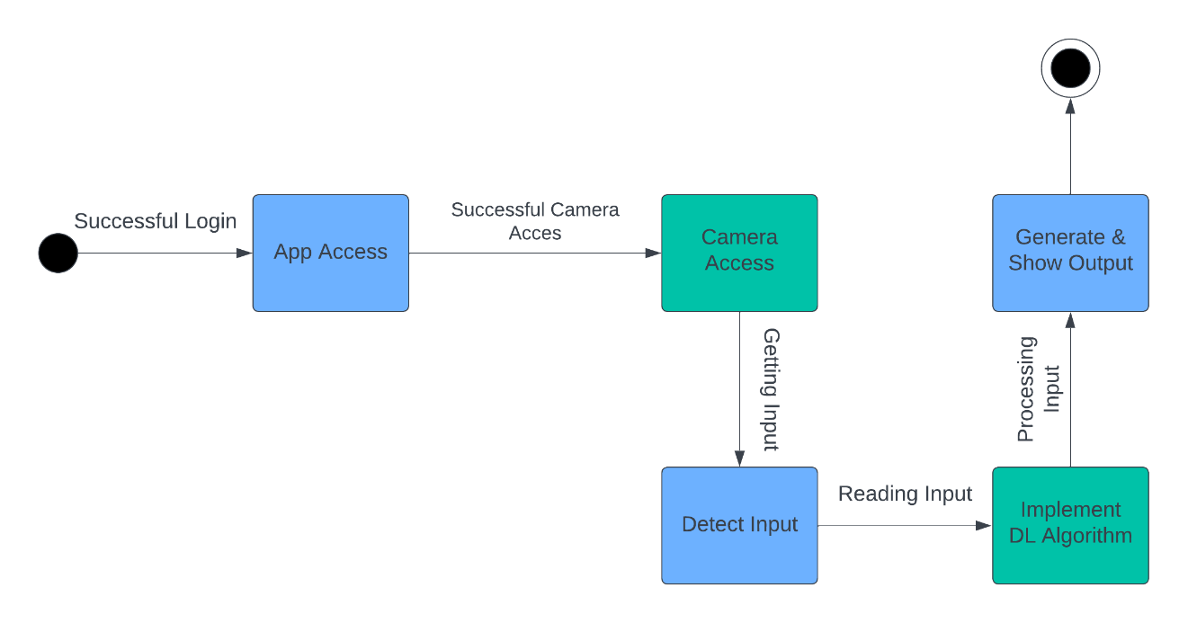
Figure 3.5 State Chart Diagram

Collaboration Diagram
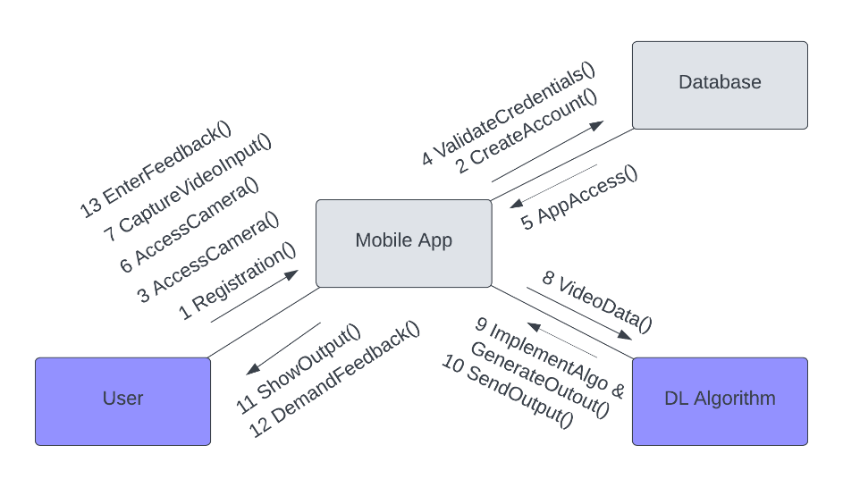
Figure 3.6 Collaboration Diagram

Chapter 4: User Interface Design

4.1. Introduction

A user interface design consists of three main parts:
Page elements should be visualized on paper before building them in the computer. Just as you draw a site map to plan the site, use cartoons and storyboards to begin blocking out the site’s appearance and navigational scheme.

- Site maps
- Storyboards
- Navigational maps

4.2. Site Maps
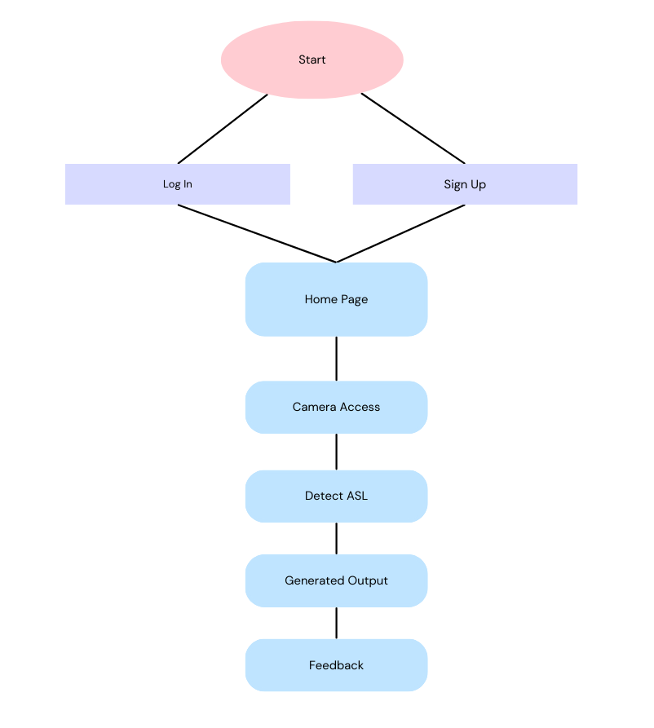
Figure 4.2 Site Map

4.3. Story boards
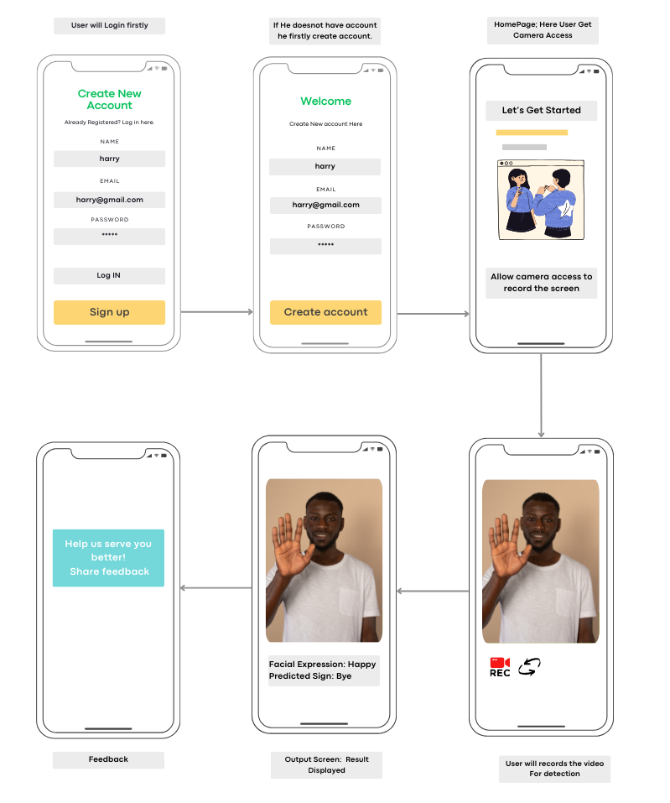
Figure 4.3 Story Board

Navigational maps:
Login Screen | 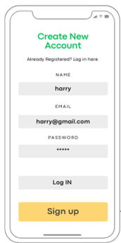 | User will Click Login Button and Will be Directed to Home Screen.  Sign Up button will take to Register Screen.
Registration Screen | 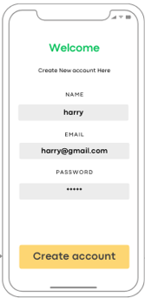 | Sign Up Screen will register user and Login him/her in App.
Camera Access on Home Screen | 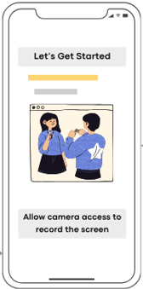 | User will get Camera Access to Input video.
Sign Language Detection Screen | 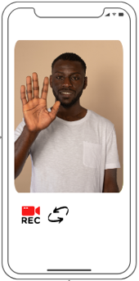 | Here through mobile front/back camera, a person will record sign language.

Output Screen | 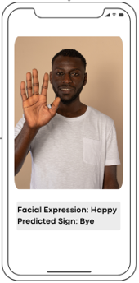 | Here the sentence of detected signs will be displayed.
Feedback Screen | 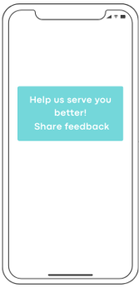 | User will provide feedback about the App.

Chapter 5: Software Testing

5.1 Introduction:
In this phase, we will discuss about the testing part of our application that is based on the IEEE standard of software testing i.e. IEEE SOFTWARE TEST DOCUMENTATION.

Following are standard artifacts, which must be included in this deliverable:
- Test Plan
- Test Design Specification
- Test Case Specification
- Test Procedure Specification
- Test Item Transmittal Report
- Test Log
- Test Incident Report
- Test Summary Report

5.2. Test plan

5.2.1. Purpose
The purpose is to ensure that all functionalities are working as expected such as System Authentication, Proper Response to user, ensure exceptions are handled and user experience is not disturbed.

5.2.2. Outline
A test plan shall have the following structure:

- Test plan identifier
- Introduction
- Test items
- Features to be tested
- Features not to be tested
- Approach
- Item pass/fail criteria
- Suspension criteria and resumption requirements
- Test deliverables
- Testing tasks
- Environmental needs
- Responsibilities
- Staffing and training needs
- Schedule
- Risks and contingencies
- Approvals

5.2.2.1. Test plan identifier
Specify the unique identifier assigned to this test plan.
SIH-TP (Silence is hearable App – Test Plan)

5.2.2.2. Introduction
In this module, we will summarize the items and features of the software to be tested.

- Project authorization;
- Project plan;
- Quality assurance plan;
- Configuration management plan;
- Relevant policies;
- Relevant standards.

5.2.2.3. Test items
- Dev Env Server Startup with Active Database Connection.
- Prod Env Server Startup with Active Database Connection.
- Auth Modules Success.
- AI Model Accuracy.
- Model Integration with System (Android).
- Camera Preview.
- Generating Text Output.

5.2.2.4. Features to be tested
- Successful Launch of Mobile App on Device.
- User Signup Success.
- User login Success.
- User Camera Access Success.
- Input Video for Sign Detection.
- Successful detection of signs.
- User Feedback Success.

5.2.2.5. Features not to be tested
All the features mentioned will be tested.

5.2.2.6. Approach
Each Module of the app will be tested. All Members will test all the functionalities individually and will report Success/Fail as result to ensure everything is working as expected and all the errors are handled properly. After successful testing, the test manager will review the test report and approve accordingly.

5.2.2.7. Item pass/fail criteria
For Server related features, server logs will be checked to ensure successful working. For Mobile App testing, UI will be thoroughly tested to ensure it is working properly and user is being properly notified.

5.2.2.8. Suspension criteria and resumption requirements
- Suspension Criteria:
- First Scenario: When all the modules have been tested successfully and everything is working as expected.
- Second Scenario: When the modules being tested are errored and need to be fixed. In this case, Development will be resumed based on the error report.
- Resumption Criteria:
  - After successful fixing of errors in testing phase, the testing shall resume.

5.2.2.9. Test deliverables
Identify the deliverable documents. The following documents should be included:
- Test plan;
- Test design specifications;
- Test case specifications;
- Test procedure specifications;
- Test item transmittal reports;
- Test logs;
- Test incident reports;
- Test summary reports.

5.2.2.10. Testing tasks
- Setting Up Development Environment (Google Colabs, Firebase, Flutter, Dart, Python, Android Studio, TensorFlow, Keras)

5.2.2.11. Environmental needs
- Mobile Device with Working Camera.
- Android v14.

5.2.2.12. Responsibilities
- Ayesha Zulfiqar & Maham Hanif is responsible for planning, developing and executing the test case scenarios.
- Noor Ul Ain is responsible for data administration and developing environment for testing.
- All members will work as Testers to ensure smooth working.

5.2.2.13 Staffing and training needs
- No Special Training for Testing is required other than giving a general overview of Mobile App.
- Providing a Document for Sign name and its respective sign.

5.2.2.14. Schedule
Testing is taken place 2 weeks before final evaluation date:
- We will need a mobile app with working camera.
- A Person any age or gender as a tester.

5.2.2.15. Risks and contingencies
The model's accuracy is the main concern. If it isn’t giving expected results then we might have to train it more. Additionally, integrating the image-based facial expression model and the video-based hand gesture model into the mobile app might pose some challenges.

5.2.2.16 Approvals

Name | Title | Signature | Date
Dr. Zafar Mehmood Khattak | Supervisor.

5.3. Test design specification

5.3.1. Purpose
Test design specification deals with the designing and predicting about the features which we are going to test. In this phase we also prioritize the test cases in their order of importance.

5.3.2. Outline
A test plan shall have the following structure:

- Test plan identifier;
- Introduction;
- Test items;
- Features to be tested;
- Features not to be tested;
- Approach;
- Item pass/fail criteria;
- Suspension criteria and resumption requirements;
- Test deliverables;
- Testing tasks;
- Environmental needs;
- Responsibilities;
- Staffing and training needs;
- Schedule;
- Risks and contingencies;
- Approvals.

5.3.2.1 Test plan identifier
Specify the unique identifier assigned to this test plan.
SIH-TP (Silence is hearable App – Test Plan)

5.3.2.2. Introduction
In the context of a mobile app, it's essential to outline and summarize the various components and features of the app that will undergo testing. This includes identifying the purpose and significance of each component or feature.

5.3.2.3. Test items
This test is to investigate the proper connection between frontend and backend along with the proper working of mobile application in providing user the right ASL response.

5.3.2.4. Features to be tested
- Successful start of Backend server.
- Successful Launch of Mobile App on Device.
- User Signup Success.
- User login Success.
- Camera Access for input.
- Video Input for Sign Detection.
- Proper Response for Detected Sign.
- User feedback on Response.

5.3.2.5. Features not to be tested
All the features mentioned will be tested.

5.3.2.6. Approach
We will be using the same strategy and approach as mentioned in the test plan phase.

5.3.2.7. Item pass/fail criteria
All core functionality of the systems should function as expected and outlined in the individual test cases. In case of error, proper message should be shown to user.

5.3.2.8. Suspension criteria and resumption requirements
The suspension and resumption criteria same as mentioned in the test plan phase.

5.3.2.9. Test deliverables
Identify the deliverable documents. The following documents should be included:
- Test plan
- Test design specifications
- Test case specifications
- Test procedure specifications
- Test item transmittal reports
- Test logs
- Test incident reports
- Test summary reports

5.3.2.10. Testing tasks
It will be same as mentioned in the test plan phase.

5.3.2.11. Environmental needs
It will be same as mentioned in the test plan phase.

5.3.2.12. Responsibilities
It will be same as mentioned in the test plan phase.

5.3.2.13. Staffing and training needs
It will be same as mentioned in the test plan phase.

5.3.2.14. Schedule
It will be same as mentioned in the test plan phase.

5.3.2.15. Risks and contingencies
It will be same as mentioned in the test plan phase.

5.3.2.16. Approvals

Name | Title | Signature | Date
Dr. Zafar Mehmood Khattak | Supervisor.

5.4. Test Case Specification

5.4.1. Purpose
The test case specification document outlines the scenarios for testing during the software testing life cycle. It defines each test's goal, inputs, expected outcomes, and provides guidance for execution. Additionally, it sets criteria for determining successful outcomes and acceptance.

5.4.2. Outline
A test case specification shall have the following structure:

- Test case specification identifier
- Test items
- Input specifications
- Output specifications
- Environmental needs
- Special procedural requirements
- Inter case dependencies

5.4.2.1. Test case specification identifier
Module_Test_Case_ID (ID will be replaced by test number)

5.4.2.2 Test items

Test Items List

- Successful start of Backend Server

Tested By | All Members
Test Case ID | Module_Test_Case_1
Test Input | Initialize the Firebase server by deploying it.
Test Output | The Firebase server will start and connect to the mobile app for user authentication.
Test Environment Required | Hardware: A PC/Laptop  Software: Firebase project configured within the mobile app.
Special procedural requirements | N/A
Inter case dependencies | N/A

- Successful Launch of Mobile App on Device.

Tested By | All Members
Test Case ID | Module_Test_Case_2
Test Input | Click Mobile App icon on your Android Device.
Test Output | The android app will launch successfully.
Test Environment Required | Hardware: Mobile Device  Software: Android OS
Special procedural requirements | N/A
Inter case dependencies | N/A

- User Signup Success.

Tested By | All Members
Test Case ID | Module_Test_Case _3
Test Input | Username, Email, Password.
Test Output | User will be successfully signed up.
Test Environment Required | Hardware: Mobile Device  Software: Android OS
Special procedural requirements | N/A
Inter case dependencies | N/A

- User login Success.

Tested By | All Members
Test Case ID | Module_Test_Case _4
Test Input | Email, Password
Test Output | User will be shown home screen and asked for Camera Access.
Test Environment Required | Hardware: Mobile Device  Software: Android OS
Special procedural requirements | N/A
Inter case dependencies | N/A

- Camera Access for input.

Tested By | All Members
Test Case ID | Module_Test_Case _5
Test Input | Permission to access Mobile Camera.
Test Output | App activates the mobile camera to capture real-time video input.
Test Environment Required | Hardware: Mobile Device  Software: Android OS
Special procedural requirements | N/A
Inter case dependencies | N/A

- Video Input for Sign Detection.

Tested By | All Members
Test Case ID | Module_Test_Case _6
Test Input | Record video of any sign input
Test Output | Detected Sign will be displayed.
Test Environment Required | Hardware: Mobile Device  Software: Android OS
Special procedural requirements | N/A
Inter case dependencies | N/A

- Proper Response for Detected Sign

Tested By | All Members
Test Case ID | Module_Test_Case _7
Test Input | Frame or Video Input
Test Output | The system displays the generated textual output to the user.
Test Environment Required | Hardware: Mobile Device  Software: Android OS
Special procedural requirements | N/A
Inter case dependencies | N/A

- User feedback on Response

Tested By | All Members
Test Case ID | Module_Test_Case _8
Test Input | App activates the user to share their feedback through a designed interface.
Test Output | The system acknowledges the successful submission of feedback to the user.
Test Environment Required | Hardware: Mobile Device  Software: Android OS
Special procedural requirements | N/A
Inter case dependencies | N/A

5.5. Test procedure specification

5.5.1. Purpose
To specify the steps for executing a set of test cases or, more generally, the steps used to analyze a software item in order to evaluate a set of features.

5.5.2 Outline
A test procedure specification shall have the following structure:

- Test procedure specification identifier
- Purpose
- Special requirements
- Procedure steps

5.5.2.1. Test procedure specification identifier
Module_Test_Procedure_ID (ID will be replaced by test number)

- Successful startup of Backend Server

Tested By | All Members
Test Procedure ID | Module_Test_Procedure_1
Purpose | To Check if the server successfully starts or not.
Special Requirement | Firebase SDK  Dependencies: Node.js, Android
Procedure Steps | Hardware: Android Device  Software: Firebase project configured within the mobile app.
Test Case ID | Module_Test_Case _1
Status | Success

- Successful Launch of Mobile App on Device.

Tested By | All Members
Test Procedure ID | Module_Test_Procedure_2
Purpose | To Check if the mobile app successfully launches or not.
Special Requirement | Android Device with v14 for smooth working of features.
Procedure Steps | Hardware: Android Device  Software: Android OS
Test Case ID | Module_Test_Case _2
Status | Success

- User Signup Success

Tested By | All Members
Test Procedure ID | Module_Test_Procedure _3
Purpose | To provide access to the features of our application.
Special Requirement | Android Device with Active Internet connection.
Procedure Steps | Hardware: Android Device  Software: Android OS
Test Case ID | Module_Test_Case _3
Status | Success

- User Login Success

Tested By | All Members
Test Procedure ID | Module_Test_Procedure _4
Purpose | To provide access to the features of our application.
Special Requirement | Android Device with Active Internet connection
Procedure Steps | Hardware: Android Device  Software: Android OS
Test Case ID | Module_Test_Case _4
Status | Success

- Camera Access for Input

Tested By | All Members
Test Procedure ID | Module_Test_Procedure _5
Purpose | To capture a Series of Signs.
Special Requirement | Permission to Access Mobile Camera.
Procedure Steps | Hardware: Android Device  Software: Android OS
Test Case ID | Module_Test_Case _5
Status | Success

- Video Input for Sign Detection

Tested By | All Members
Test Procedure ID | Module_Test_Procedure _6
Purpose | To detect Sign being made in a video.
Special Requirement | Permission to Access Mobile Storage.
Procedure Steps | Hardware: Android Device  Software: Android OS
Test Case ID | Module_Test_Case _6
Status | Success

- Proper Response for Detected Sign

Tested By | All Members
Test Procedure ID | Module_Test_Procedure _7
Purpose | To Acknowledge User about the results.
Special Requirement | N/A
Procedure Steps | Hardware: Android Device  Software: Android OS
Test Case ID | Module_Test_Case _7
Status | Success

- User Feedback on Response

Tested By | All Members
Test Procedure ID | Module_Test_Procedure _8
Purpose | To take response from user for predicted result correctness.
Special Requirement | Internet connection to send response back to server.
Procedure Steps | Hardware: Android Device  Software: Android OS
Test Case ID | Module_Test_Case _8
Status | Success

5.6. Test item transmittal report

5.6.1. Purpose
To identify the test items being transmitted for testing. It includes the person responsible for each item, its physical location, and its status. Any variations from the current item requirements and designs are noted in this report.

5.6.2. Outline
A test item transmittal report shall have the following structure:

- Transmittal report identifier
- Transmitted items
- Location
- Status
- Approvals

5.6.2.1. Transmittal report identifier
MTTRI_ID (ID will be replaced by test number)

5.6.2.2. Transmitted items
All the items which are mentioned in the Test Plan are part of the test transmittal report. We three members working in this project are responsible for test planning and specification development as indicated in Testing Responsibilities.

5.6.2.3. Location
All the tests and their specification will be shared through a valid communication channel to test manager.

5.6.2.4. Status
All the test items provided at this stage are only tested by developers and not by the other members. In case of any error, other members will report that back to test manager for fixing and further development.

5.6.2.5. Approvals

Name | Title | Signature | Date
Dr. Zafar Mehmood Khattak | Supervisor.

5.7. Test log

5.7.1. Purpose
To provide a chronological record of relevant details about the execution of tests.

5.7.2. Outline
A test log shall have the following structure:
- Test log identifier;
- Description;
- Activity and event entries.

5.7.2.1. Test log identifier
MTTL_ID (ID will be replaced by test number)

5.7.2.2. Description
All the items are tested. The testing of our Mobile App is conducted manually.

5.7.2.3. Activity and event entries
Identifier | Activity | Time | Expected Output | Actual Output | Tested By
MTTL_1 | MTC_1 | June | Backend Server should start. | As expected | All Members
MTTL_2 | MTC_2 | June | Mobile app should launch. | As expected | All Members
MTTL_3 | MTC_3 | June | User should be able to sign up and access system. | As expected | All Members
MTTL_4 | MTC_4 | June | User should be able to login and access system. | As expected | All Members
MTTL_5 | MTC_5 | June | Mobile app should receive input from camera. | As expected | All Members
MTTL_6 | MTC_6 | June | Input video to perform prediction. | As expected | All Members
MTTL_7 | MTC_7 | June | View output of prediction. | As expected | All Members
MTTL_8 | MTC_8 | June | Prediction result response taken from user. | As expected | All Members

5.7.2.3.1. Execution description
Every member of the team tested each function.

5.7.2.3.2. Procedure results
Identifier | Activity | Procedure Performed | Tested By | Result
MTTL_1 | MTP_1 | Backend Server should start | All Members | Successful
MTTL_2 | MTP_2 | Mobile app should launch. | All Members | Successful
MTTL_3 | MTP_3 | User should be able to sign up and access system. | All Members | Successful
MTTL_4 | MTP_4 | User should be able to login and access system. | All Members | Successful
MTTL_5 | MTP_5 | Mobile app should receive the input from camera. | All Members | Successful
MTTL_6 | MTP_6 | Input video to perform prediction | All Members | Successful
MTTL_7 | MTP_7 | View output of prediction | All Members | Successful
MTTL_8 | MTP_8 | Prediction result response taken from user. | All Members | Successful

5.7.2.3.3. Environmental information
- Hardware Specification
  - Android Mobile
  - Laptop
- Software Specification
  - Python libraries
  - Google Colabs
  - Flutter & dart
  - Firebase
  - Android Studio

5.7.2.3.4. Anomalous events

5.7.2.3.4.1 Anomalous identifier
MTAE_ID (ID will be replaced by test number)

Identifier | Event | Tested By
MTAE _1 | Insufficient RAM in Google colabs necessitates extra memory acquisition for processing video. | All Members
MTAE _2 | User should be able to login and access system. | All Members
MTAE_3 | Integrated model struggle with both shorter and longer inputs. | All Members

5.7.2.3.5. Incident report identifiers
Test Case Identifier | Test Procedure Identifier | Test Log Identifier | Anomalous Event Identifier
MTC_1 | MTP_1 | MTTL_1 | MTAE _1
MTC_2 | MTP_2 | MTTL_2 | MTAE _2
MTC_3 | MTP_3 | MTTL_3 | MTAE_3
MTC_4 | MTP_4 | MTTL_4
MTC_5 | MTP_5 | MTTL_5
MTC_6 | MTP_6 | MTTL_6
MTC_7 | MTP_7 | MTTL_7
MTC_8 | MTP_8 | MTTL_8
MTC_9 | MTP_9 | MTTL_9

5.8. Test incident report

5.8.1. Purpose
To document any event that occurs during the testing process that requires investigation.

5.8.2. Outline
A test incident report shall have the following structure:

- Test incident report identifier
- Summary
- Incident description
- Impact

5.8.2.1. Test incident report identifier
MTTI_ID (ID will be replaced by test number)

5.8.2.2. Summary

Identifier | Test Item | Test Case | Test Procedure
MTTI_1 | Successful startup of Backend Server | MTC_1 | MTP_1
MTTI_2 | Successful Launch of Mobile App on Device. | MTC_2 | MTP_2
MTTI_3 | User Signup Success | MTC_3 | MTP_3
MTTI_4 | User Login Success | MTC_4 | MTP_4
MTTI_5 | Camera Access for signs Input | MTC_5 | MTP_5
MTTI_6 | Video Frames Input for Sign Detection. | MTC_6 | MTP_6
MTTI_7 | Proper Response for Detected Sign | MTC_7 | MTP_7
MTTI_8 | User Feedback on Response | MTC_8 | MTP_8

5.8.2.3. Incident description
MTTI_6 introduced prediction issue for short and longer videos, fixed by specifying duration of input.

5.8.2.4.Impact
MTTI_6 had a significant impact ,as it occurred in a primary feature of app.

5.9. Test summary report

5.9.1. Purpose
To summarize the results of the designated testing activities and to provide evaluations based on these results.

5.9.2. Outline
A test summary report shall have the following structure:
- Test summary report identifier
- Summary
- Variances
- Comprehensive assessment
- Summary of results
- Evaluation
- Summary of activities
- Approvals

5.9.2.1. Test summary report identifier
MTTS_ID (ID will be replaced by test number)

5.9.2.2. Summary
All items passed successfully and the performance issue for MTTI_6 was fixed.

5.9.2.3. Variances
No Variance occurred. Every test was executed according to test plan and design.

5.9.2.4. Comprehensiveness assessment
The testing process is done exactly like described in the test plan. All the features described in the test plan are tested.

5.9.2.5. Summary of results
All the test cases mentioned passed successfully as described in the test plan.

5.9.2.6. Evaluation
Backend: All the APIs have been tested through Postman.
Mobile App: Each module of mobile app has been tested in both Debug and Release mode and in multiple devices.

5.9.2.7. Summary of activities
Test Item | Test Case | Result
Successful startup of Backend Server | 3-June-2023 | Successful Execution
Successful Launch of Mobile App on Device. | 3-June-2023 | Successful Execution
User Signup Success | 3-June-2023 | Successful Execution
User Login Success | 3-June-2023 | Successful Execution
Camera Access Success | 3-June-2023 | Successful Execution
Video Input for Sign Detection. | 3-June-2023 | Successful Execution
Proper Response for Detected Sign | 3-June-2023 | Successful Execution
User Feedback on Response | 3-June-2023 | Successful Execution

5.9.2.8. Approvals

Name | Title | Signature | Date
Dr. Zafar Mehmood Khattak | Supervisor.

Chapter 6: Results

- Model 1 (facial expression):

Original Dataset
Data | No. of Samples | No. of Classes | Avg. Data in Class
Train Set | 57,642 | 7 | 3172
Validation Set | 14, 132 | 7 | 802

Used Dataset
Data | No. of Samples | No. of Classes | Avg. Data in Class
Train Set | 28,821 | 7 | 2493
Validation Set | 7,066 | 7 | 620

- Model 2 (hand gestures):

Original Dataset
Data | No. of Samples | No. of Classes | Avg. Data in Class
Train Set | 1,62,068 | 50 | --
Validation Set | 32,413 | 50 | --

- Used Dataset (Due to Lack of Computational Resources)
Data | No. of Samples | No. of Classes | Avg. Data in Class
Train Set | 62,008 | 25 | 250-300
Validation Set | 15,501 | 25 | --

Model is Trained on The Following Architecture:

Model 1 (facial expression):
- Model: Sequential CNN
- Activation Conv2D: Relu.
- Activation Dense: softmax
- Batch Size: 32
- Epochs: 50
- Input shape: (48, 48, 1)

Model 2 (hand gestures):
- Model: Sequential LSTM
- Activation Dense: softmax
- Batch Size: 32
- Epochs: 100
- Input shape: (20, number_of_features)

Final Results for Model 1:
Accuracy | Val Accuracy | Loss | Val Loss
73% | 61% | 34% | 341%

Final Results for Model 2:
Accuracy | Val Accuracy | Loss | Val Loss
99% | 97% | 20% | 201%

Justification for Results
- These are the final results of our trained AI Models, utilizing face and hand landmarks for facial and sign recognition.
- The models have demonstrated strong performance across most tested classes, indicating effective learning and generalization.

Limitations
- There were computational issues that necessitated purchasing more RAM due to the diverse video dataset.
- Facial data had some variations, making landmarks essential for accurate recognition.
- The results could have been improved but were restricted due to computational power issues with the large dataset and more samples.
- The high number of samples resulted in prolonged training times, with each epoch taking around 10+ hours.
- Termination of sessions or unstable internet issues often led to the cancellation of training.

Prediction Results

Model: Facial Expression | Model: Hand Gesture
Actual label: Surprise  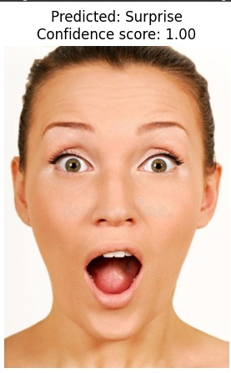 | Actual label: Doctor  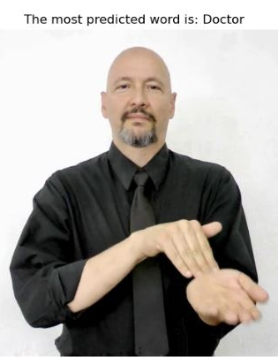
Actual label: Happy  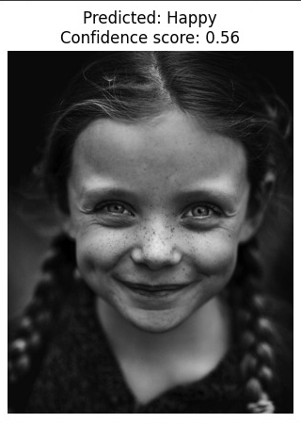 | Actual label: Cook  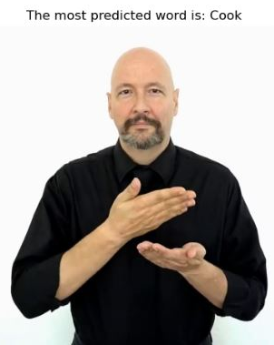

Testing Results
Performance:

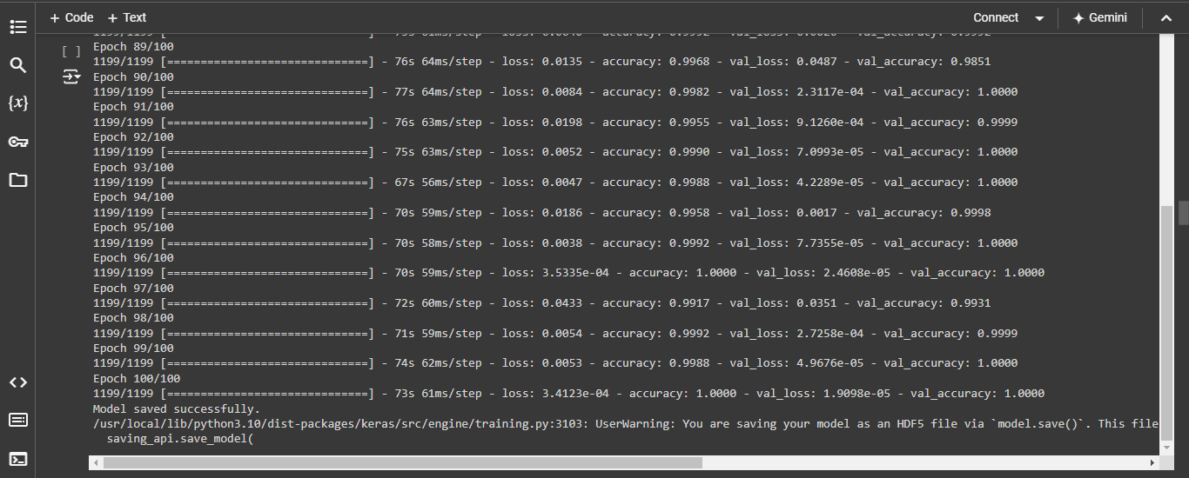

Predictions:

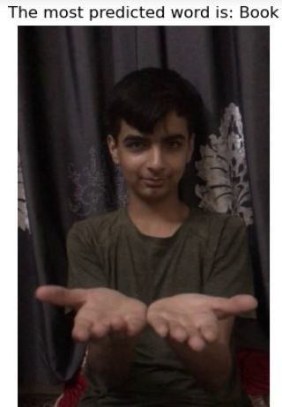

Increasing the number of classes in a model typically leads to higher loss and variability in accuracy due to the increased complexity of distinguishing between more categories. This also demands more computational resources for training, as the model needs to learn and differentiate more features.

Chapter 7: User Manual

      - Splash Screen
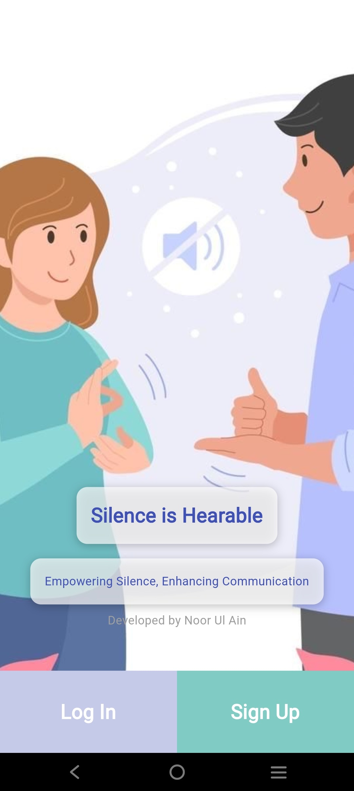

On launching the application, this is the first screen that appears when the user launches the application.
On this screen, following two buttons are embedded:
- Log In Button: Upon tapping the Log In button, the application navigates to the Login Screen.
- Sign Up Button: Upon tapping the SignUp button, the application navigates to the Sign Up Screen.

      - Login Screen:

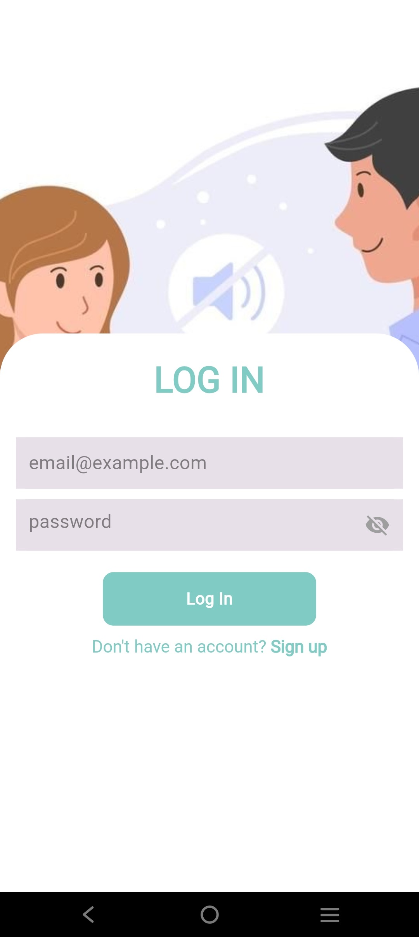

This is the Login Screen which is triggered by in response to the Log In Button on the Splash Screen. The Login Screen contains the following:
- Two Text Fields:
- Email Field (In this field, the user is prompted to enter the email address which they used at the time of registering as user of the application).
- Password Field (This field prompts the user to enter the correct password which they used at the time of signing up for the account).
- Log In Button: After entering the correct email address & correct password in the text fields, the user must click on the Log In button to navigate to Home Screen of the application.
- Sign Up Text (Embedded Gesture Detector): Below the Log In button, there is text (Don’t have an account? Sign Up) which prompts you to tap on it if you do not have an account for using the application.
On tapping this text, the gesture detector, navigates the application to the Sign Up Screen.

      - Sign Up Screen:

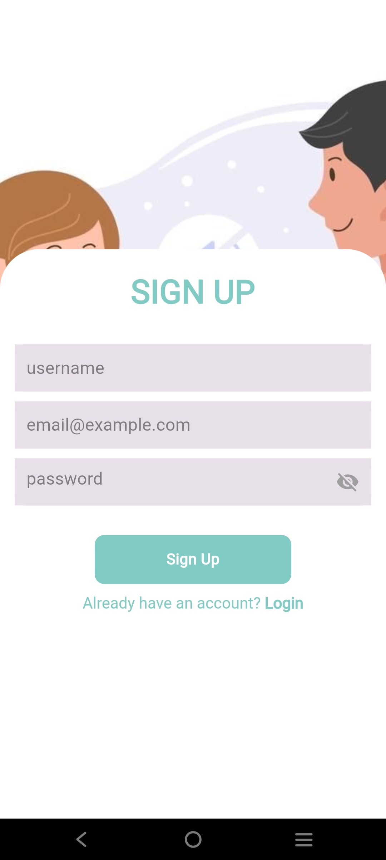

The above screen is the Sign Up Screen, which appears when the user taps on either the Splash Sign Up Button from the Splash Screen or when the user taps on “Don’t have an account? Sign Up” Gesture Detector embedded on the Login Screen.

This screen has the following functionality:
- Three Text Editing Fields (Username Field, Email Field, and Password Field)
- Username Field: This field prompts the user to enter the username which they want.
- Email Field: This field prompts the user to enter any email address irrespective of domain such as (Google, Yahoo, Hotmail, Outlook etc.)
- Password Field: This field prompts the user to setup a password which they will use in future whenever they want to login to the application.
- Sign Up Button: After entering all the required credentials, the user must tap on Sign Up button to successfully sign up for the application.
After the user is registered, the application navigates to the Login Screen.
- Gesture Detector (“Already have an account? Login”): If the user already has an account he/she must tap on this text “Already have an account? Login”, on tapping it, the application navigates to the Login Screen.
      - Home Screen:
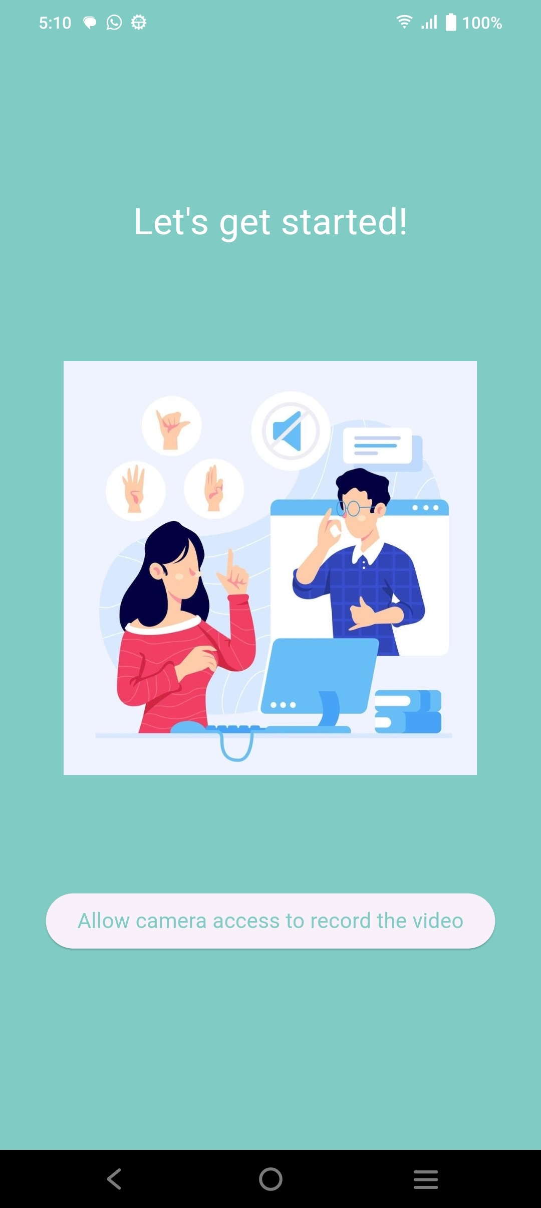

This is the Home Screen containing a button with the text “Allow camera access to record the video”.
- On clicking the button, the user is prompted with the following Alert Dialogue Box:
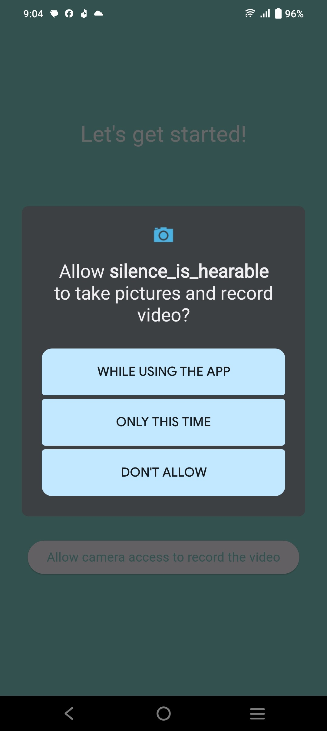

In this Alert Dialogue Box, the user must grant the camera permission to record the video. Upon granting the necessary camera permission, the application navigates to the Camera Screen.
      - Camera Screen:

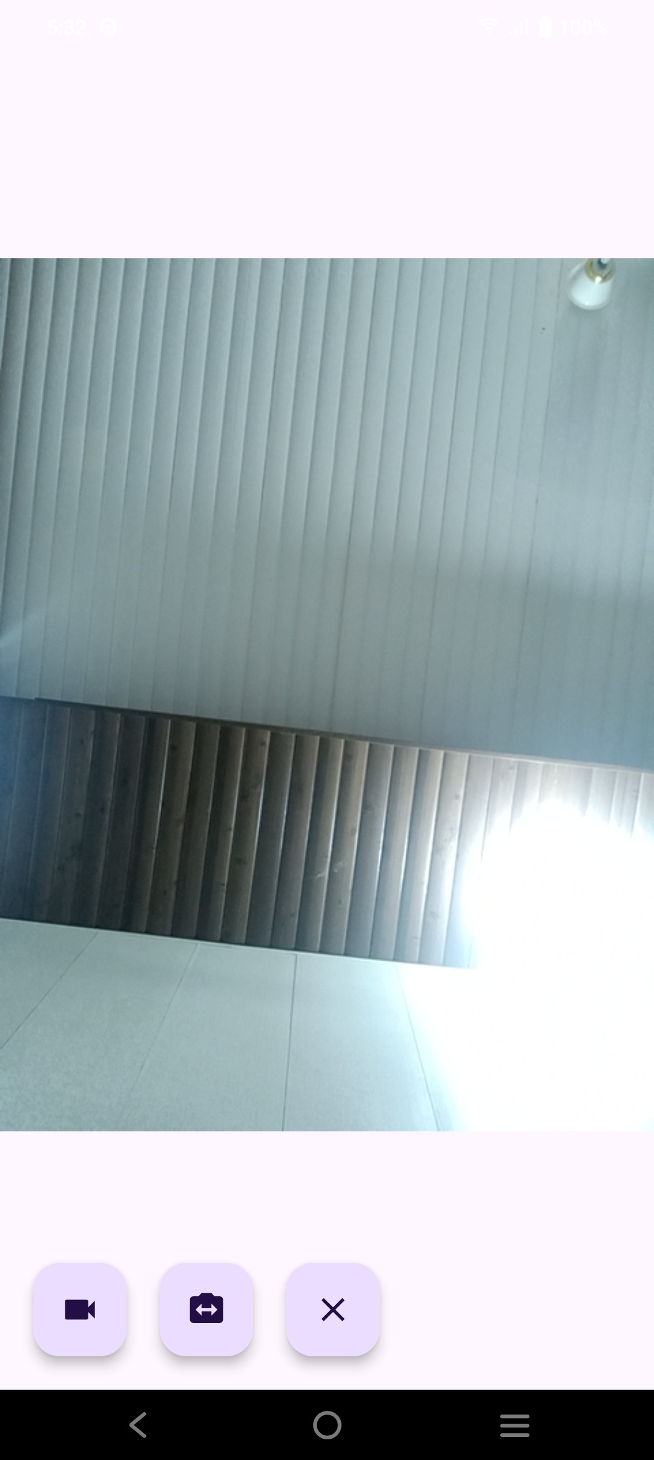

This is the Camera Screen having three buttons:
            - Toggle Recording: This button is used for turning on the video recording and turning off the video recording.
            - Toggle Camera: This button is used for switching between front & rear cameras view.
            - Clear Output: This button is used for clearing the predictions result.

On successfully getting the predictions results the following alert dialogue box is displayed at user interface to capture the feedback and show the output.

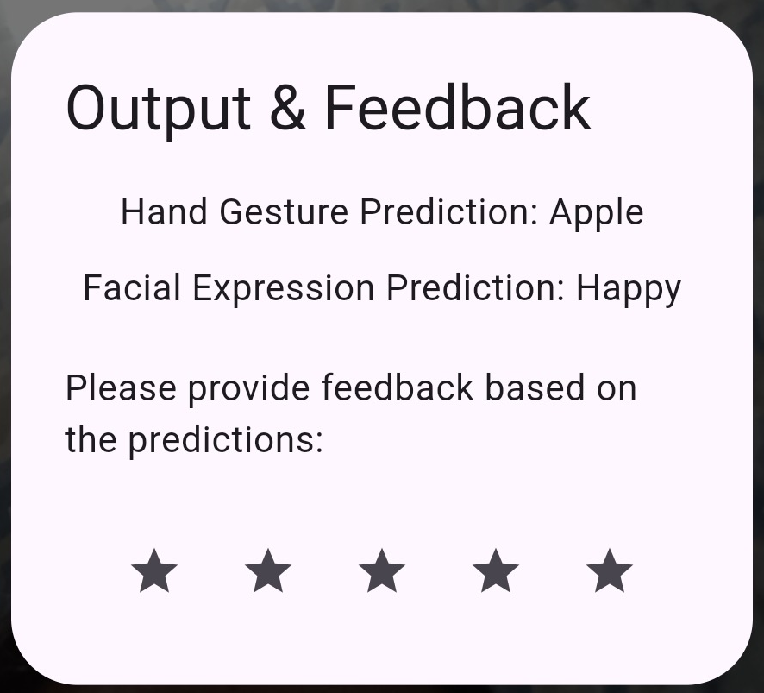

In this alert dialogue box, the user can give the feedback which is optional. If the user doesn’t want to give the feedback, he can click on anywhere the screen to return to camera preview screen.

Chapter 8: Conclusion and Future Work

  - Conclusion:
In conclusion to our work, we will write the challenges, problems, work done and results to our work.
- Challenges:
- Gathering of Dataset
- Select best AI Technique to train our model on.
- Keeping the system from crashing for longer hours of training.
- Problems:
- Increasing dataset enough to train our model for proper training.
- Termination of Model’s epoch training due to internet or server connection lost.
- Work Done:
- Developed Mobile Application for Sign Language Detection.
- Trained AI Model on Sign Language Dataset with an Accuracy of 94%

  - Future Work
- Detect Sign Language Gestures and generate short sentences.
- Convert Text to Sign Language.

